Design Critique 7  
*name*: Lonneke Lammers   
*studentnumber*: 10371672

*Write a short paper of about 3 pages in which you critically evaluate visualization and suggest improvements and refinements. Examine this visualisation carefully, all the interactive components and accompanying text:*[*Job Market Tracker*](http://graphics.wsj.com/job-market-tracker/)*.*

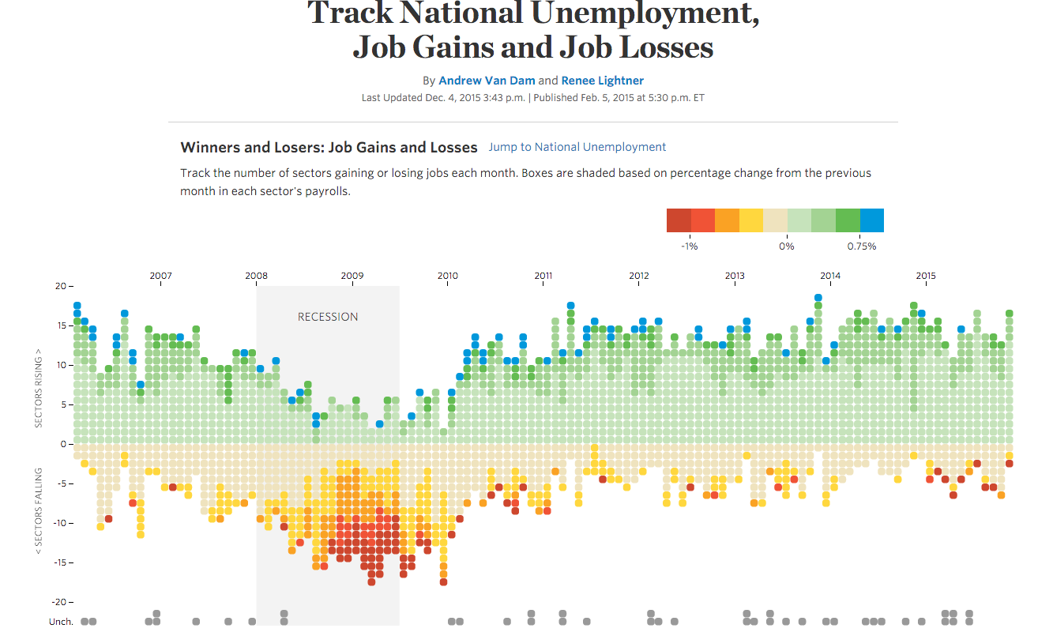  
*source:* [*http://graphics.wsj.com/job-market-tracker/*](http://graphics.wsj.com/job-market-tracker/)

**The visualisation**In this visualisation the viewer gets an inside of job gains and job losses per sector. It provides information per month from february 2006 untill the end of 2015. It shows the recession starting in 2008 in light-grey, en also shows the sectors without any gains or losses ond the bottom of the visualisation in dark-grey.

Furder you can scroll down to see more specifications and details about the particular sectors (sector name, sector size, monthly change in total jobs and in percent, month’s rising and month’s falling. This part is interactive with the the visualisation (shown above).

The second visualisation represents the national unemployment from 1948 untill 2015, which is seasonally adjusted. It stays in contact with the visualisation beneath, which gives an overview of the overall unemployment rate by a linegraph. Here, you can adjust both charts by selecting gender, age, race and degree of education.

**Graphical** **integrity**  
Tufte describes six principles of graphical integrity:

1. The representation of numbers, as physically measured on the surface of the graphic itself, should be directly proportional to the numerical quantities represented.
2. Clear, detailed, and thorough labeling should be used to defeat graphical distortion and ambiguity. Write out explanations of the data on the graphic itself. Label important events in the data
3. Show data variation, not design variation.
4. In time-series displays of money, deflated and standardized units of monetary measurement are nearly always better than nominal units
5. The number of information-carrying (variable) dimensions depicted should not exceed the number of dimensions in the data
6. Graphics must not quote data out of context  
   *source:* [*http://www.albertsuckow.com/tuftes-principles-graphical-integrity/*](http://www.albertsuckow.com/tuftes-principles-graphical-integrity/)

I think this visualisation doesn’t fulfill principle three, but fulfills the first, second, fourth, fifts and sixth principle. This means it scores high on the graphical integrity principles of Tufte.

The representation is done with dots stacked on top of each other. On the left size of the visualisation counts the amount of sectors rising. This representation of numbers is directly proportional to the numberical quantity that is measured. The labeling is in my opinion quite clear. It represents the sector, the increase or decrease percentage and the month plus year. The third principle is not reallt met. There is no consistent size of the dots which represents the grow in percents. Every dot is the same size, but sometimes jobs gain with 3 percent and sometimes with 7 percent. This scaling factor is not completely right. But when I’m thinking of a solution for this problem, I think that it might make the visualisation less clear if you add a real correct lenght of the dot. Then the fourth principle is met, where it shows the user the percent of gain or loss of jobs in a visualised way with labeling. Then the number of information-carrying dimensions depicted do not exceed the number of dimensions in the date. It is nice scaled and no unnecessary white space, which helps is lowering the Lie-factor, which is in my opinion low. Also the data-ink ratio is quite high where there is not so much white space, but this ratio can be optimized by making the dots the right vertical length of how much the sector gained or lost. Last but not least, the graphics does not quote data out of context. I think this visualisation is quite clear in what it wants to show you, without chartjunk.

*source:* [*http://thedoublethink.com/2009/08/tufte%E2%80%99s-principles-for-visualizing-quantitative-information/*](http://thedoublethink.com/2009/08/tufte%E2%80%99s-principles-for-visualizing-quantitative-information/)

**Graphic design principles**  
Graphic designer and best selling author Robin Williams explains five graphic design principles in her book “The Non-Designer’s Design Book”. These principles are proximity, alignment, repetition, contrast and white space. Some of these principles are already discussed above.

This visualisation groups data together by date, which gives the viewer and overview of changes by time in gains and losses of jobs. Not per sector, which would also have been a possibilty. But I think grouping by time is a much better manner as done in the visualisation because it gives you a good insight in how economy goes from time to time. The alignment is clear, where most labels are displayed on a consistent way. The Detailed View has a clear repetition, which looks like a table. On the left side the sector name on alphabetical order, followed by the sector size and the montly change in jobs and percent. Again, the usage of colors is still confusing. Furder is white space minimized by making the scales in the right way.

Another aspect is contrast. The colors choice used in the visualisation would not be my first choice. They use red for losses of 1%, then use orange for approximately 0,5% loss, different hue’s of green for around 0,5% gain and then end with blue where there is a gain of more than 0.75%. It’s a pretty random choice of colors, which is not a good manner to visualize following D. Borland and R. M. Taylor II, who describe in their article “Rainbow Color Map (Still) Considered Harmful” that it’s much better to make use of one color with different hue’s.

*source:* [*http://www.makeuseof.com/tag/5-basic-principles-graphic-design-take-granted-everyday/*](http://www.makeuseof.com/tag/5-basic-principles-graphic-design-take-granted-everyday/)

**The visual encodings**  
J. Heer and B. Shneiderman discuss the importance of visual encodings in their article “[Interactive Dynamics for Visual Analysis](http://cdn.mprog.nl/dataviz/excerpts/w5/p30-heer.pdf)”. By choosing the right visual encoding the maker can make a visualisation good or bad, or easy to understand or hard. The main visual encoding that A. Van Dam and R. Lightner used in their visualisation about job gains and job losses are length of lines and color. It’s actually not a real line, but a line of stacked dots. But those dots together are being count: how many sectors are rising and how many are falling.

**Goal of visualisation**  
The goal of this visualisation is to give an insight to which sectors had a hard time during for example the recession, or maybe another time-period. By a user’s own knowlegde someone could maybe explain why a particular sector was rising or falling in amount of jobs and thus was probably doing well at that moment.

**Improvement**  
I think this is a good visualisation, but there are some aspects which could be improved. Firstly the way of color usage. Already mentioned above is this rainboy coloring not a good way to visualize this data, following D. Borland and R. M. Taylor II. They could have used a better color palette, for example …

*Full sources of articles mentioned:*

*- D. Borland and R. M. Taylor II, “*[*Rainbow Color Map (Still) Considered Harmful*](http://cdn.mprog.nl/dataviz/excerpts/w4/Borland_Rainbow_Color_Map.pdf)*”, IEEE Computer Graphics and Applications, vol. 27, no. 2, pp. 14–17, 2007.*

*- J. Heer and B. Shneiderman, “*[*Interactive Dynamics for Visual Analysis*](http://cdn.mprog.nl/dataviz/excerpts/w5/p30-heer.pdf)*”, ACM Queue, Feb 1, 2012.*

This is a list of points to consider when critiquing a design, consider them conversation starters.

• What is the problem domain or context of the visualization under consideration?

• Which tasks can be achieved with this visualization?

• Tufte’s principles of graphical integrity:

* Are the scales appropriately labeled?
* Is the Lie factor high?
* Does the visualization show data variation and not design variation?

• Tufte’s visualization design principles, are they adhered to?

* Maximize the data-ink ratio.
* Avoid chart junk.
* Increase data density.
* Layer information.

• Graphic design principles:

* How is contrast used? What kind of contrast is used?
* How is repetition used?
* How is alignment used?
* How is proximity used?

• Comment on the visual encodings that are used.

* Which visual encodings are used?
* Are the visual encodings appropriate?

• Comment on subjective dimensions such as aesthetics, style, playfulness and vividness.

• What is the intended goal of the visualization and is that goal achieved?

• Are there any things you would do differently, and why?